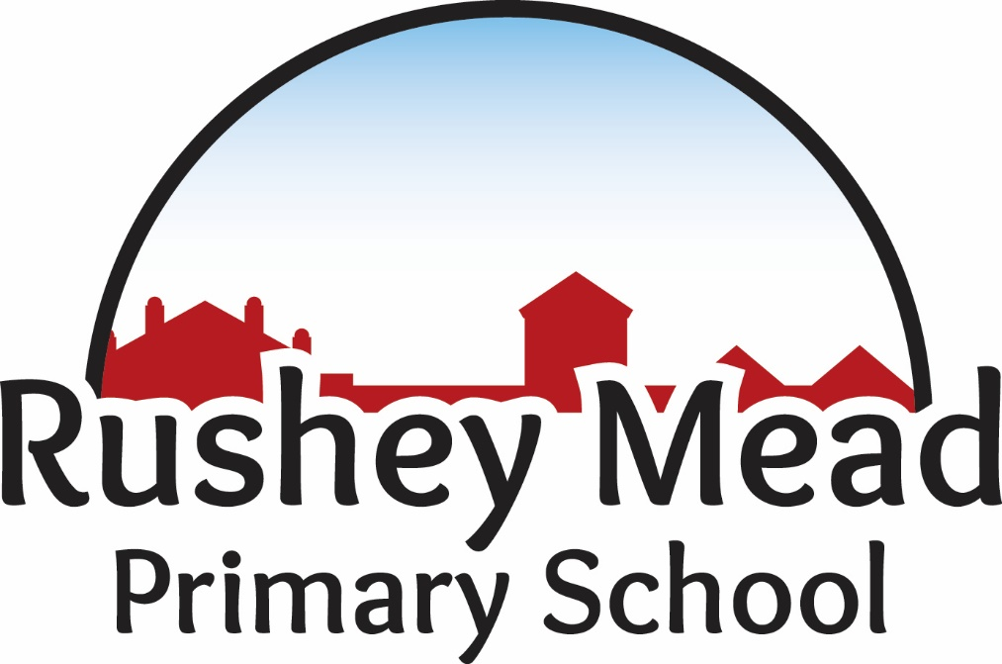

English as an Additional Language (EAL) Policy

Policy Date: | June 2024 |  | Version: 1.1
Policy Review Date: | June 2028 |  | Headteacher  Nitash Odedra
Ratified by Governing Body:
Sue Welford (Chair of Governors)

Introduction
All pupils need to feel safe, accepted and valued in order to learn. For pupils who are learning English as an additional language, this includes recognising and valuing their home language and background. As a school, we are aware that bilingualism is a strength and that EAL pupils have a valuable contribution to make. At Rushey Mead, we take a whole school approach to our school ethos and values, British Values, our 6 School Character Traits, the curriculum, anti-bullying and promoting language acquisition.
The government’s definition of an EAL learner is:

‘A child with English as an additional language is one who was exposed to a language other than English during their early years and continues to be exposed to this language in the home or in the community.’

Aims
This policy aims to raise awareness of the school’s obligations and to support the planning, organisation, teaching and assessment procedures, and the use of resources and strategies to meet the needs of pupils who have English as an additional language (EAL) and so to raise pupil achievement.

School Context
Rushey Mead Primary School is situated to the north of the city of Leicester serving a community that is rich in a diversity of language, faith and culture. The school’s priority area is compact and mainly consists of Victorian terraced housing. We admit children from the age of 3 and most children transfer at the age of eleven to either Rushey Mead Academy or Soar Valley College. At the present time we have approximately 600 children on roll.
For about 95% of the children English is an additional language, the first language for the majority of the children being Gujarati. The largest faith community is Hindu.
The school is housed in a two storey, early 1900s brick building. Some of the building has been refurbished. All of the classrooms are of a good size. We have two large halls, a studio, a library, a pupil kitchen, a community room and a staff workroom. To the rear of the school are hard and grassed play areas. Our sports field is adjacent to the school with a running track.
Information is gathered about:
- Pupils’ linguistic background and competence in other language/s
- Pupils’ previous educational experience
- Pupils’ family and biographical background
A member of staff is nominated to have responsibility for EAL. Currently this is Natasha Jackson who is our EAL Lead.

Key Principles of additional language acquisition
‘EAL pupils have a right to access the National Curriculum and the Early Years Foundation Stage. This is best achieved within a whole school context. Pupils learn more quickly when socialising and interacting with their peers who speak English fluently and can provide good language and learning role models.’ Ofsted 2014
- The home languages of all pupils and staff should be recognised and valued. Pupils should be encouraged to maintain their home language and use it in the school environment particularly for New Arrivals wherever possible.
- Although many pupils acquire the ability to communicate on a day-to-day basis in English quite quickly, the level of language needed for academic study is much deeper and more detailed, and can require continuing support for up to ten years
- There are three main EAL groups, which include:
- Beginner Learners – Children who are in their first two years of learning English.
- Intermediate Learners – Children who have been learning English for between two and five years.
- Advanced Learners – Children who have had most or all of their school education in the U.K.
- Language develops best when used in purposeful contexts across the curriculum
- The language demands of learning tasks need to be identified and included in planning
- Teaching and support staff play a crucial role in modelling uses of language
- Knowledge and skills developed in learning the first language aid the acquisition of additional language
- A clear distinction should be made between English as an additional language (EAL) and Special Educational Needs and Disabilities (SEND)

Assessment
All EAL pupils are entitled to assessments as required. Progress in the acquisition of English will be regularly assessed and monitored using the Nassea EAL Assessment Framework.

Planning, Monitoring and Evaluation
- Targets for EAL pupils are appropriate, challenging and reviewed on a regular basis
- Planning for EAL pupils incorporates curriculum objectives, which take into account whether the child is a beginner, intermediate or advanced EAL learner
- Staff regularly observe, assess and record information about pupils’ developing use of language
- When planning the curriculum, staff take into account the linguistic, cultural and religious backgrounds of learners

Teaching Strategies
Classroom activities have clear learning objectives and use appropriate strategies to support EAL learners to participate in lessons and access the mainstream curriculum.
- Key language features of each curriculum area, e.g. key vocabulary, language functions and forms of text are identified
- Opportunities are provided for speaking and listening, including both process and presentational talk, and use made of drama techniques and role play. This is alongside collaborative activities that involve purposeful talk and encourage and support active participation
- The classroom is organised so that pupils have access to effective staff and peer models of spoken language. This includes placing EAL learners in appropriate groups
- Additional visual support is provided, e.g. Widgit symbol software, posters, pictures, photographs, objects, diagrams and graphic organisers
- Additional verbal support is provided, e.g. repetition, modelling and opportunities for oral rehearsal
- Scaffolding is provided for language and learning, e.g. talk frames, writing frames, models and graphic organisers

Special Educational Needs and Disabilities and Gifted and Talented Pupils
- Most EAL pupils needing additional support do not have SEND
- Should SEND be identified, EAL pupils have equal access to school’s SEND provision
- If EAL pupils are identified as Gifted and Talented, they have equal access to the school’s G&T provision

New Arrivals
Prior to admission (once all the relevant forms have been completed) a member of the of the Admin team will meet with parents to discuss and share relevant information and provide a tour of the school. At this point any parental questions are answered. Any pupil information regarding Special Educational Needs and Disabilities (SEND) will be shared and discussed with the SENCo.
Termly, the class teacher will update their Nassea assessments and report them to the EAL Lead for everyone involved to be able to monitor progress.

Parental / Community Involvement
Staff strive to encourage parental and community involvement by:
- Providing a welcoming induction process for newly arrived pupils and their families / carers
- Using plain English and translators and interpreters, where appropriate and available, to ensure good spoken and written communications
- Identifying linguistic, cultural and religious backgrounds of pupils and establishing contact with wider community where possible
- Celebrating and acknowledging the achievements of EAL pupils in the wider community
- Recognising and encouraging the use of first language
- Helping parents understand how they can support their children at home, especially by continuing the development of their first language

Roles and Responsibilities
All staff are responsible for ensuring that all pupils, including EAL pupils achieve their full potential. These responsibilities will be detailed in the job descriptions of all staff.
Staff will be kept up to date with current, local and national EAL updates.

