Uniform Policy

Policy Date: | November 2025 |  | Version: 1
Policy Review Date: | November 2028 |  | Headteacher:  Nitash Odedra | 
Ratified by Governing Body:
Chair of Governors: Sue Welford |  |  |   Insert Signature

Contents
1. Aims 2
2. Our school’s legal duties under the Equality Act 2010 2
3. Limiting the cost of school uniform 2
4. Expectations for school uniform 3
5. Expectations for our school community 4
6. Monitoring arrangements 5
7. Links to other policies 5

1. Aims
This policy aims to:
- Set out our approach to requiring a uniform that is of reasonable cost and offers the best value for money for parents and carers
- Explain how we will avoid discrimination in line with our legal duties under the Equality Act 2010
- Clarify our expectations for school uniform

2. Our school’s legal duties under the Equality Act 2010
The Equality Act 2010 prohibits discrimination against an individual based on the protected characteristics, which include sex, race, religion or belief, and gender reassignment.
To avoid discrimination, our school will:
- Avoid listing uniform items based on sex, to give all pupils the opportunity to wear the uniform they feel most comfortable in or that most reflects their self-identified gender
- Make sure that our uniform costs the same for all pupils
- Allow all pupils to have long hair (though we reserve the right to ask for this to be tied back)
- Allow all pupils to style their hair in the way that is appropriate for school yet makes them feel most comfortable
- Allow pupils to request changes to swimwear for religious reasons
- Allow pupils to wear headscarves and other religious or cultural symbols
- Allow for adaptations to our policy on the grounds of equality by asking pupils or their parents to get in touch with school and we will answer questions about the policy and respond to any requests

3. Limiting the cost of school uniform
Our school has a duty to make sure that the uniform we require is affordable, in line with statutory guidance from the Department for Education on the cost of school uniform.
We understand that items with distinctive characteristics (such as branded items, or items that have to have a school logo or a unique fabric/colour/design) cannot be purchased from a wide range of retailers and that requiring many such items limits parents’ ability to ‘shop around’ for a low price.
We will make sure our uniform:
- Is available at a reasonable cost
- Provides the best value for money for parents/carers
We will do this by:
- Carefully considering whether any items with distinctive characteristics are necessary
- Limiting any items with distinctive characteristics where possible for example, we do not require school jumpers to be emblazoned with the school logo
- Avoiding specific requirements for items pupils could wear on non-school days, such as coats, bags and shoes
- Avoiding different uniform requirements for different year/class/house groups
- Avoiding different uniform requirements for extra-curricular activities
- Considering alternative methods for signaling differences in groups for interschool competitions, such as creating posters or labels
- Making sure that arrangements are in place for parents to acquire second-hand uniform items
- Avoiding frequent changes to uniform specifications and minimising the financial impact on parents of any changes
- Consulting with parents and pupils on any proposed significant changes to the uniform policy and carefully considering any complaints about the policy

4. Expectations for school uniform
4.1 Our school’s uniform

- A red jumper with optional school logo
- A white polo t-shirt or shirt
- Black or grey trousers, shorts, skirts or pinafore dresses
- Black school shoes or plimsolls
- Red checked summer dresses
- Suitable and safe jewellery e.g. a watch, religious jewellery, stud earrings
- For PE: A white polo t-shirt and black tracksuit or shorts (dependent on weather) and trainers
- For swimming: Appropriate swimming costume or trunks (swimming hats if required)
- Any suitable coats or bags (branded bookbags are available, but not required)
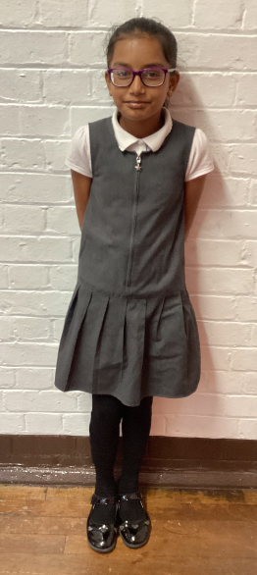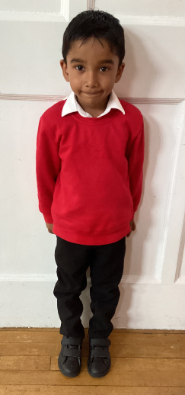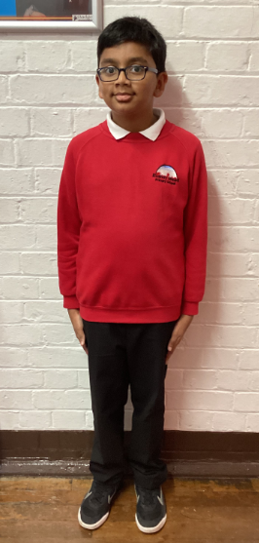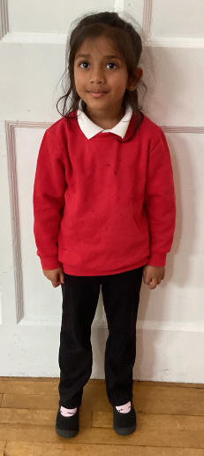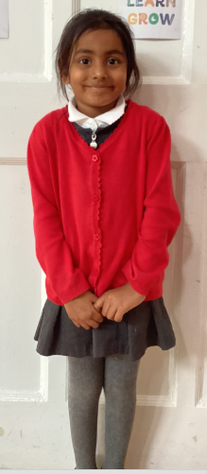

4.2 Where to purchase it
- Parents and carers can obtain branded uniform items from https://just-schoolwear.co.uk/product-category/rushey-mead-primary/
- Parents and carers can obtain unbranded uniform from many high street retailers, supermarkets and local clothes-wear shops
- Second hand uniform:
  - Unclaimed, clean lost property is available to take free of charge at the end of every half term and at school events for example, parents’ evening (any unclaimed items will be donated to a local charity shop or clothes bank).
  - We encourage any unwanted or outgrown uniform to be passed on to siblings or family friends. Donations will be accepted if it is in good condition and we will also offer this to families at the end of half term.

5. Expectations for our school community
5.1 Pupils
Pupils are expected to wear the correct uniform at all times (other than specified non-school uniform days) while:
- On the school premises
- Travelling to and from school
- At out-of-school events or on trips that are organised by the school, or where they are representing the school (if required)
Pupils are also expected to contact The Headteacher if they want to request an amendment to the uniform policy in relation to their protected characteristics.
5.2 Parents and carers
Parents and carers are expected to make sure their child has the correct uniform and PE kit, and that every item is:
- Clean
- Clearly labelled with the child’s name
- In good condition
- Fits the child
Parents are also expected to contact The Headteacher if they want to request an amendment to the uniform policy in relation to:
- Their child’s protected characteristics
- The cost of the uniform
Parents are expected to lodge any complaints or objections relating to the school uniform in a timely and reasonable manner.
Disputes about the cost of the school uniform will be:
- Resolved locally
- Dealt with in accordance with our school’s complaints policy
The school will work closely with parents to arrive at a mutually acceptable outcome.

5.3 Staff
Staff will closely monitor pupils to make sure they are in correct uniform. They will give any pupils and families breaching the uniform policy the opportunity to comply, but will follow up with the headteacher if the situation doesn’t improve.
Ongoing breaches of our uniform policy will be dealt with by The Headteacher.
In cases where it is suspected that financial hardship has resulted in a pupil not complying with this uniform policy, staff will take a mindful and considerate approach to resolving the situation.

5.4 Governors
The governing board will review this policy and make sure that it:
- Is appropriate for our school’s context
- Is implemented fairly across the school
- Takes into account the views of parents and pupils
- Offers a uniform that is appropriate, practical and safe for all pupils
The board will also make sure that the school’s uniform supplier arrangements give the highest priority to cost and value for money, for example by avoiding single supplier contracts and by re-tendering contracts at least every 5 years.

6. Monitoring arrangements
This policy will be reviewed every 3 years by The Headteacher. At every review, it will be approved the school’s governing body.

7. Links to other policies
This policy is linked to our:
- Behaviour policy
- Equality information and objectives statement
- Anti-bullying policy
- Complaints policy

