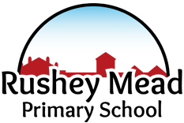

Palm Class and Elm Class

Our Reception classes are:

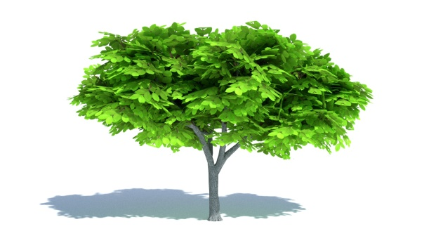
What can you do to help?
As children start in Reception they will be doing a lot of learning about sounds and letters of the alphabet. To support your child with this it would be helpful for them to get used to holding a pencil correctly and to practise writing their own name.
Children will be taught to form letters in pre-cursive style.

A a B b C c D d E e F f G g H h
I i J j K k L l
M m N n O o P p Q q R r S sT t
U u V v W w X x Y y Z z

What is my classroom like?
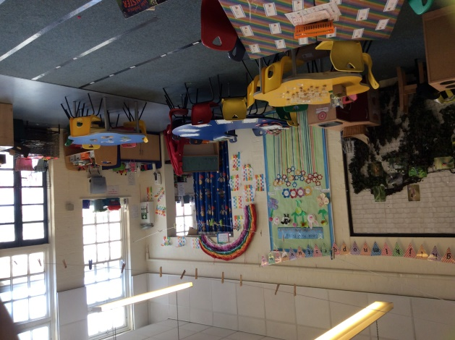
The children in Reception are split into two classes; Palm class and Elm class. Your child will have their own teacher but we encourage all of our children to share their learning with each other! With this in mind our classrooms are open and shared and children can choose which room they wish to enjoy during our ‘freeflow’ time.

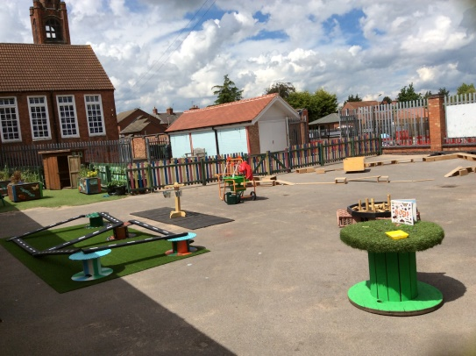
We also have access to a large outdoor area which children can choose throughout the day!
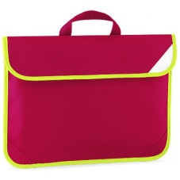
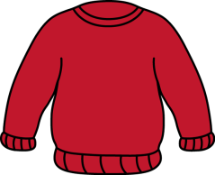
Uniform
All children should be wearing the school's uniform, as this shows a collective discipline and also gives the children a sense of belonging.
The school uniform includes:
- A red jumper or sweatshirt, preferably with the school logo on it.
- White polo shirt or white shirt to be worn underneath the sweatshirt.
- Dark-coloured skirt or trousers.
- Black school shoes that are suitable for both inside and outside.

Please ensure that all items of clothing contain your child’s name to prevent it from getting lost.
Book Bags
We encourage children to take books home to share with members of their family. In order to do this all children need to have a bag that is used only for books. The bag does not need to be of any special type but we do ask that it has your child’s name on it!
Lunch Time!
You may choose for your child to have a packed lunch from home or a school dinner!
Children who are under the age of 7 are entitled to a free school dinner.
Please let us know at your parents meeting which meal choice you would like for your child.

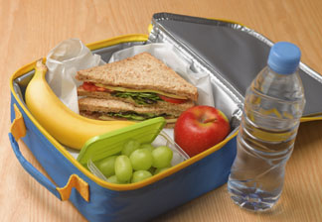
We are a ‘healthy school' so we kindly ask that you do not send;
- Chocolate
- Sweets
- Fizzy drinks

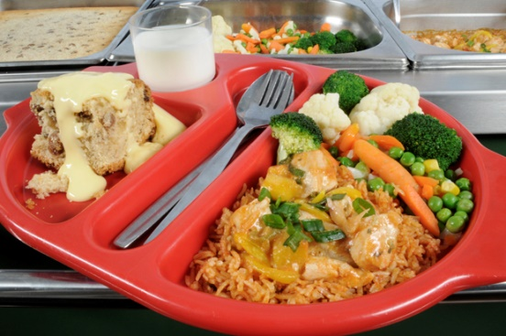
Our school meals offer both a meat and vegetarian option!

We are a Nut free school!
What can you do to help?
You can help your child by promoting independence. Examples include:
- Being able to dress themselves without help.
- Being able to use the toilet and wash hands without adult help.
- Being able to put on and zip own coat and shoes without help.
- Being able to write their own name.
- Being able to recognise and write some numbers 0-10.

To make the first mornings of school a little easier for your child it may be helpful to get them used to saying goodbye to you. This may be through spending half an hour at a friend’s house without you and will help to ensure they have a fantastic first day!
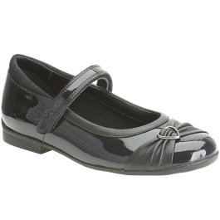
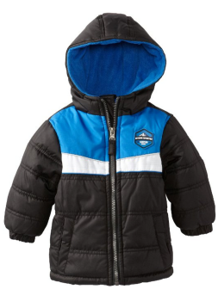

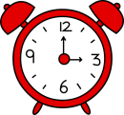
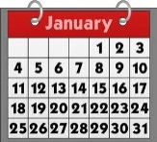
Important dates:
The first morning of school will be: 31st August 2021
- Parents will be invited to meet their child’s teacher for half an hour on either the 25th, 26th or 27th August. Please wait for your appointment.
- 31st August- Children start school AM only.
- 2nd and 3rd September- Children will stay for lunchtime and go home at 1.30pm.
- 6th September- Children will be in school for full day.

Rushey Mead Primary School is a happy, caring, school community. We hope that this booklet will have given you the information you need before your child starts at our school. However, please come along to the school for a visit or chat if you have any further queries.
Rushey Mead Primary School
Gipsy Lane, Leicester. LE4 6RB
Telephone: (0116) 266 1114 Fax:(0116) 261 2920
E-mail: office@rusheymead-pri.leicester.sch.uk
Website: www.rusheymead-pri.leicester.sch.uk

Headteacher: Mrs D Bailey.
Deputy Head: Mr N Odedra.

